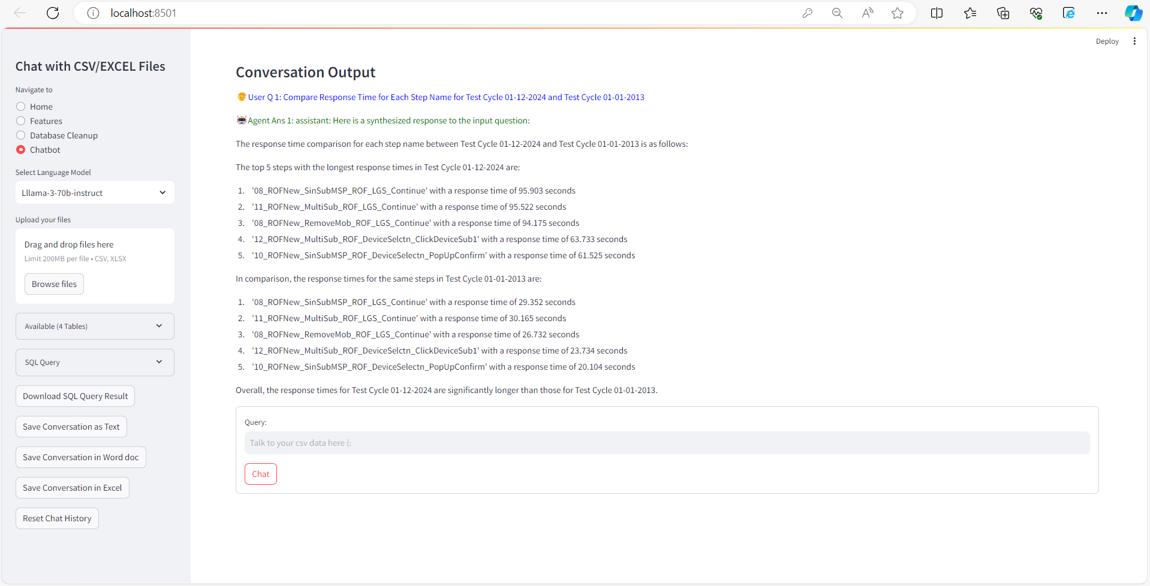

You can also see query in Side Panel of Screen

*SELECT WPC_Cycle_1.Step_name, WPC_Cycle_1.ResponseTime, WPC_Cycle_2.ResponseTime*

*FROM WPC_Cycle_1*

*JOIN WPC_Cycle_2 ON WPC_Cycle_1.Step_name = WPC_Cycle_2.Step_name*

*WHERE WPC_Cycle_1.Test_cycle = '01-Dec' AND WPC_Cycle_2.Test_cycle = 'Jan-13'*

*ORDER BY WPC_Cycle_1.ResponseTime DESC;*

SELECT WPC_Cycle_1.System, WPC_Cycle_1.Build_version, WPC_Cycle_1.Test_cycle, WPC_Cycle_1.Scenario, WPC_Cycle_1.Step_name, WPC_Cycle_1.Avg_latency_s_, WPC_Cycle_2.Avg_latency_s_ FROM WPC_Cycle_1 INNER JOIN WPC_Cycle_2 ON WPC_Cycle_1.System = WPC_Cycle_2.System AND WPC_Cycle_1.Build_version = WPC_Cycle_2.Build_version AND WPC_Cycle_1.Test_cycle = WPC_Cycle_2.Test_cycle AND WPC_Cycle_1.Scenario = WPC_Cycle_2.Scenario AND WPC_Cycle_1.Step_name = WPC_Cycle_2.Step_name ORDER BY ABS(WPC_Cycle_1.Avg_latency_s_ - WPC_Cycle_2.Avg_latency_s_) DESC;

SELECT

WPC_Cycle_1.Test_cycle,

WPC_Cycle_1.Avg_latency_s_,

WPC_Cycle_2.Avg_latency_s_,

WPC_Cycle_1.Error_count,

WPC_Cycle_2.Error_count

FROM

WPC_Cycle_1

INNER JOIN WPC_Cycle_2

ON WPC_Cycle_1.System = WPC_Cycle_2.System

AND WPC_Cycle_1.Build_version = WPC_Cycle_2.Build_version

AND WPC_Cycle_1.Scenario = WPC_Cycle_2.Scenario

AND WPC_Cycle_1.Step_name = WPC_Cycle_2.Step_name

ORDER BY

WPC_Cycle_1.Test_cycle,

WPC_Cycle_1.Avg_latency_s_ - WPC_Cycle_2.Avg_latency_s_ DESC;

SELECT WPC_Cycle_1.System, WPC_Cycle_1.Test_cycle, WPC_Cycle_1.Scenario, WPC_Cycle_1.Step_name, WPC_Cycle_1.Success_count, WPC_Cycle_1.Error_count,

WPC_Cycle_2.System, WPC_Cycle_2.Test_cycle, WPC_Cycle_2.Scenario, WPC_Cycle_2.Step_name, WPC_Cycle_2.Success_count, WPC_Cycle_2.Error_count

FROM WPC_Cycle_1

JOIN WPC_Cycle_2 ON WPC_Cycle_1.System = WPC_Cycle_2.System AND WPC_Cycle_1.Test_cycle = WPC_Cycle_2.Test_cycle AND WPC_Cycle_1.Scenario = WPC_Cycle_2.Scenario AND WPC_Cycle_1.Step_name = WPC_Cycle_2.Step_name

ORDER BY WPC_Cycle_1.Success_count DESC, WPC_Cycle_2.Error_count ASC;

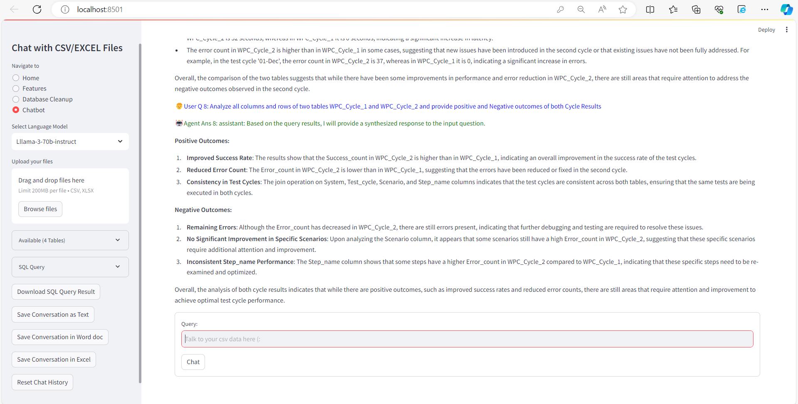



Prompts:

1. Compare Response Time for Each Step Name for Test Cycle 01-12-2024 and Test Cycle 01-01-2013.
2. Compare two tables WPC_Cycle_1 and WPC_Cycle_2 and provide comparison result of Response Time in tabular format based on Step Name
3. Compare two tables WPC_Cycle_1 and WPC_Cycle_2 and provide comparison result of Response Time based on Step Name in tabular format with addition of change in %age and show separately trend and analysis of result.
4. Compare two tables WPC_Cycle_1 and WPC_Cycle_2 and provide your Analysis based on result and suggest improvement points.
5. Compare two tables WPC_Cycle_1 and WPC_Cycle_2 and provide positive and Negative outcomes of both Cycle Results
6. Analyse all columns and rows of two tables WPC_Cycle_1 and WPC_Cycle_2 and provide positive and Negative outcomes of both Cycle Results

You can also monitor End to End Flow

Earlier we were getting in chatbot window maximum 7 rows but after some changes in config, we are getting more than 50 rows and detailed analysis based on maximum ~ 120 to 150 rows.



